Quick Installation Guide
Before installing, make sure you are using Window 95/98. To setup our product, please turn off your computer. Follow the instructions step by step.

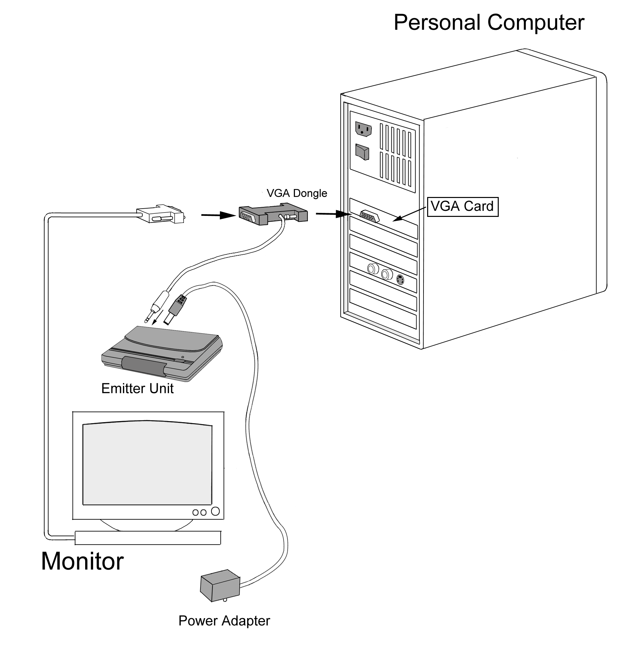

Hardware Setup
- Place the Alkaline battery (23A/12V) into the LC shutter glasses. (As shown below)

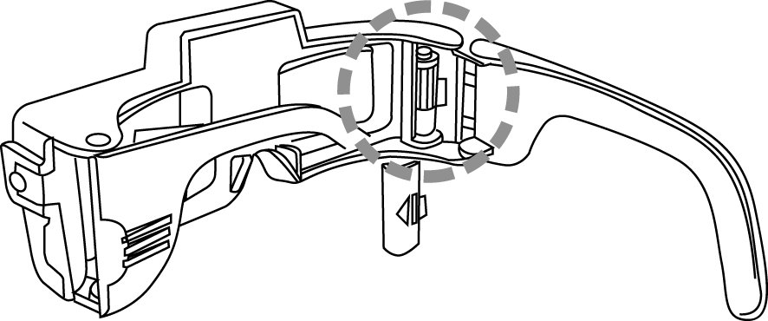
- Place the emitter on the top of your color monitor. Connect the power adapter to the emitter and plug it into the surge protector. Set the LINE BLANKER switch to OFF.
- Plug the VGA dongle (15 PIN male) into your VGA port, and attach the monitor connector to the VGA dongle (15 PIN female). (As shown below)
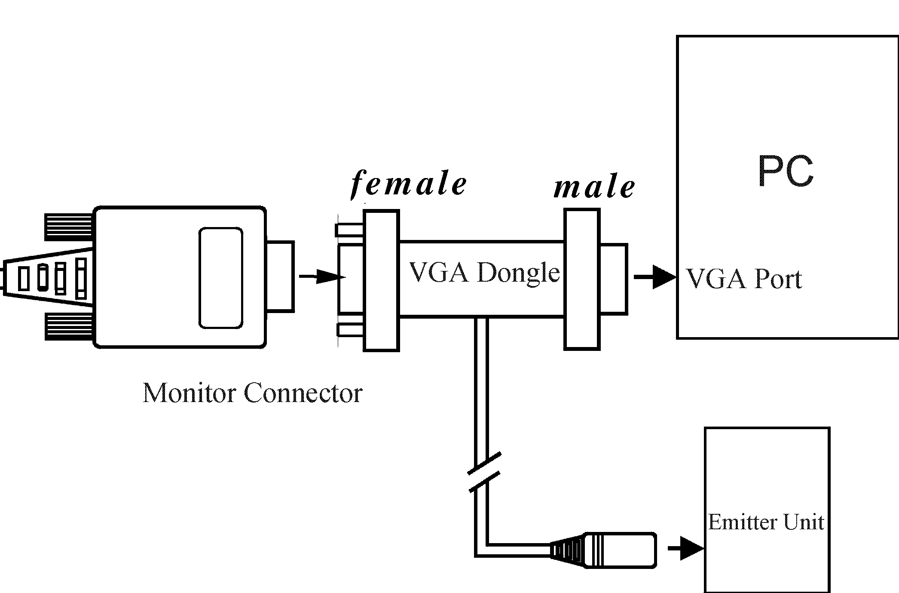

- Plug the VGA dongle’s MINI DIN-8 into the emitter.
- Turn on your computer. The LED of the emitter should be RED.
Using Line Blanker to View Stereoscopic Images
After installing your Eye3D hardware, you can use the line-blanking function to view the interleaved images as long as your VGA card can support a 120 Hz refresh rate. Simple steps to get Eye3D line-blanking features working:
- Place your i-Art 3DShowcase CD in your CD-ROM drive.
- Double-click on your CD-ROM drive and select the [Virtual Gallery Demo] folder and run [VG.exe].
- Turn ON the emitter’s Line Blanker switch (the LED of the emitter should be GREEN). Put on your LC shutter glasses and activate them to view stereoscopic images.

Using 3DWin to View Stereoscopic Images
After installing your Eye3D hardware, you can use the interlacing function to view stereoscopic images. Follow these simple steps to get Eye3D interlacing features working:
- Place your i-Art 3DShowcase CD in your CD-ROM drive.
- Double-click your CD-ROM drive and select the [3DWin English] folder to run [Setup.exe].
- After successful installation, choose the [3D Mode] tag from 3DWin and set 3D on. (As shown below)
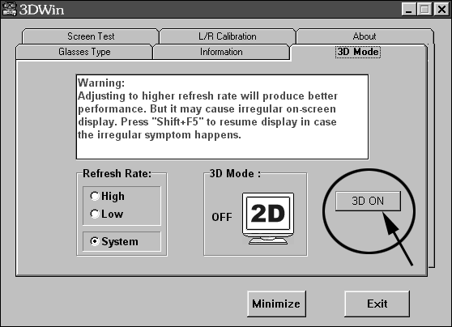
- Click your CD-ROM drive and select the [Virtual Gallery Demo] folder and run VG.exe.
Note: When 3DWin does not work with your VGA card, you can still turn ON the emitter’s Line Blanker switch and run [VG.exe] in the [Virtual Gallery Demo] directory. However if the refresh rate is less than 120Hz in your Display Properties settings, the LC shutter glasses will flicker.

Using Eye3D Stereoscopic Game Driver CD
After installing your Eye3D hardware, you can use the sync-doubling function to play your favorite PC games. Note: Please ensure the Line Blanker switch on the emitter is OFF while you are playing stereoscopic games. When the sync-doubling function is working, the LED of the emitter should be AMBER.
- Place your Eye3D Driver CD in your CD-ROM drive.
- The auto-run feature will start and the installation process will begin. (If the menu does not automatically show up: double-click your CD-ROM drive and select Eye3D.exe.)
- After successful installation, reboot your computer. Note: For full Eye3D driver functionality, DirectX 6.0 or higher must be installed. If DirectX 6.0 or higher is not installed, install DirectX 6.0 from the DirectX directory on the Eye3D CD.
- Run your favorite PC game. (Please check the details in Eye3D Stereoscopic Eyewear Driver Users Manual on the Eye3D Driver CD.)
- We strongly recommend you install Eye3D Activator 1.0 on i-Art 3DShowcase. You can use Eye3D Activator to help you toggle between sync-doubling and normal mode.

Enjoy!
While entering stereo mode, please put on your Eye3D LC shutter glasses. Just press its small Push Button (as shown below) to activate and adjust the stereoscopic images. This small Push Button is used to (1) turn power on/off (2) reverse left/right image.

